2021 Survey of Occupational Injuries and Illnesses (SOII)
In 2021, approximately 58,300 nonfatal workplace injuries and illnesses were reported through the Bureau of Labor Statistics’ Survey of Occupational Injuries and Illnesses by Maryland’s private sector and State and local government employers.
The injuries and illnesses occurred at a rate of 2.9 cases per 100 full-time equivalent workers. This rate was an increase from the previous year‘s rate of 2.6 per 100 full-time equivalent workers. The Survey of Occupational Injuries and Illnesses or (SOII) is a cooperative program between the Maryland Department of Labor, Licensing and Regulation, Division of Labor and Industry and the U.S. Department of Labor, Bureau of Labor Statistics.
In 2021 there were approximately 2.4 million workers in the State under the Maryland Occupational Safety and Health (MOSH) agency’s regulatory oversight.
Maryland’s Private Sector
Maryland’s private sector employers reported 45,800 nonfatal injuries and illnesses for 2021 compared to 42,400 reported in 2020. Injuries and illnesses in private industry occurred at a rate of 2.7 cases per 100 equivalent full-time workers in 2021. Cases of a more serious nature involving days away from work, job transfers, or restrictions -- commonly referred to as the DART rate, occurred at a rate of 1.7 cases per 100 full-time equivalent workers. There were 29,300 such cases reported. Rates of injury and illness in the private sector ranged from a total recordable case incidence rate of 0.4 injuries and illnesses per 100 full-time equivalent workers for Computer and electronic product manufacturing (NAICS 334) to a rate of 16.7 for Air transportation (NAICS 481).
Eighty-six percent of private industry’s reported injuries and illnesses occurred in service-providing industries with 39,300 cases while goods-producing industries accounted for 14 percent of the total with 6,500 cases. Injury and illness estimates for Maryland’s private sector covered just under 2.1 million workers, based on the Maryland Department of Labor, Licensing and Regulation’s labor market information and the Quarterly Census of Employment and Wages program.
Maryland’s private sector total recordable case rate of 2.7 injuries and illnesses per 100 full-time equivalent workers was the exact same as the U.S. private sector’s rate of 2.7.
Maryland’s State and Local Government
Collectively, Maryland state and local government agencies reported 12,500 new cases of occupational injury and illness in 2021 with a total recordable case (TRC) incidence rate of 4.7 injuries and illnesses per 100 full-time equivalent workers. Local government accounted for approximately 78 percent of the public sector cases.
In 2021, the Maryland State government’s TRC rate was 3.2 injury and illness cases per 100 full-time equivalent workers as compared to the previous year’s rate of 3.0. Maryland state government’s TRC rate in 2021 was the same as the U.S. rate for all state government.
Industries in State government reporting the highest rates in 2021 were Hospitals (13.4), Nursing and residential care facilities (12.9), and Transit and ground passenger transportation (10.4).
Of the 2,700 total cases reported during 2021 by Maryland state government (compared to the 2,500 cases reported the previous year) approximately 1,500 cases were severe enough to require the employee to miss at least one day from work for recuperation. Maryland’s local government sector reported 9,800 new cases of occupational injury and illness in 2021. Approximately 3,600 cases resulted in days away from work.
Maryland State and local government municipalities and agencies employed some 329,244 workers during 2021, based on data provided by the Maryland Department of Labor, Licensing and Regulations’ Office of Workforce Information and Performance, Quarterly Census of Employment and Wages program.
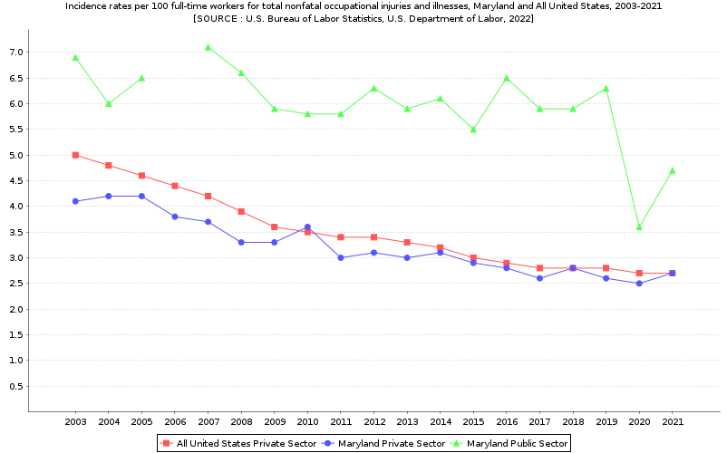
*2006 Maryland Public Sector data did not meet publication criteria

Year | All United States Private Sector | Maryland Private Sector | Maryland Public Sector
2003 | 5.0 | 4.1 | 6.9
2004 | 4.8 | 4.2 | 6.0
2005 | 4.6 | 4.2 | 6.5
2006 | 4.4 | 3.8 | -
2007 | 4.2 | 3.7 | 7.1
2008 | 3.9 | 3.3 | 6.6
2009 | 3.6 | 3.3 | 5.9
2010 | 3.5 | 3.6 | 5.8
2011 | 3.4 | 3.0 | 5.8
2012 | 3.4 | 3.1 | 6.3
2013 | 3.3 | 3.0 | 5.9
2014 | 3.2 | 3.1 | 6.1
2015 | 3.0 | 2.9 | 5.5
2016 | 2.9 | 2.8 | 6.5
2017 | 2.8 | 2.6 | 5.9
2018 | 2.8 | 2.8 | 5.9
2019 | 2.8 | 2.6 | 6.3
2020 | 2.7 | 2.5 | 3.6
2021 | 2.7 | 2.7 | 4.7
*2006 Maryland Public Sector data did not meet publication criteria

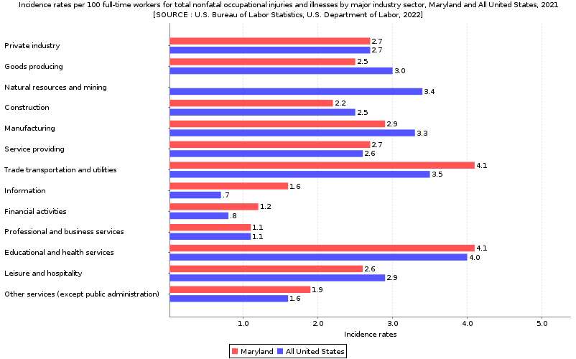
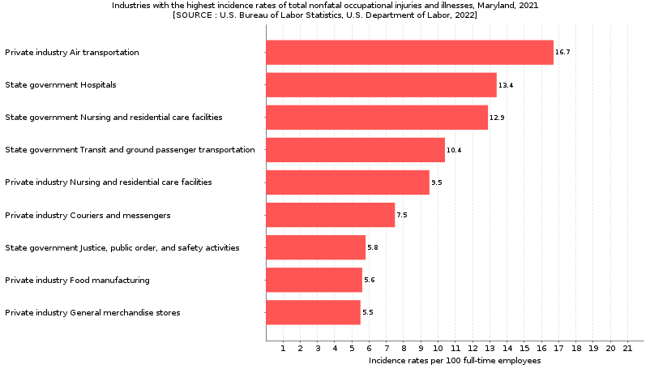
Additional Information
The Survey of Occupational Injuries and Illnesses (SOII) is a cooperative program between the State of Maryland’s Department of Labor, Licensing and Regulation, Division of Labor and Industry and the U.S. Department of Labor, Bureau of Labor Statistics. The SOII presents estimates of counts and incidence rates of employer reported nonfatal workplace injuries and illnesses by industry and type of case. BLS has generated estimates of nonfatal occupational injuries and illnesses for many industries as defined in the 2017 North American Industry Classification System (NAICS) manual. Occupational injury and illness statistics have been published for Maryland’s private sector every year since 1972 and for Maryland state and local government from 1979 forward.
The SOII program also provides details on the circumstances and characteristics of the more seriously injured and ill workers. Estimates involving days away from work (DAFW) by detailed case characteristics and worker demographics for 2021 are not published in this release. In the Fall of 2023, SOII will begin biennial publication for DAFW and days of job transfer or restriction (DJTR) for the period 2021-2022. Estimates for detailed industry by case type are unchanged.
SOII relies on OSHA recordkeeping requirements, which mandate employers record certain work-related injuries and illnesses on their OSHA 300 log, including the recording of cases of COVID-19, see www.osha.gov/coronavirus/standards.
All comparison statements made in this news release are statistically significant at the 95 percent confidence level. Additional background and methodological information regarding the BLS occupational safety and health statistics program is in the BLS Handbook of Methods at www.bls.gov/opub/hom/soii/home.htm. Additional data from the SOII are available on the BLS website at www.bls.gov/iif.
State and National data Tables can be found at the Federal BLS website at www.bls.gov/iif/state-data.htm.

