MOSH INSTRUCTION:

INSTRUCTION NUMBER: 21-1 | EFFECTIVE DATE: August 27, 2021
SUBJECT: MOSH COVID-19 Pandemic Field Enforcement Guidelines | ISSUANCE DATE: August 27, 2021
CANCELLATION: None | EXPIRATION: One year from the effective date above unless cancelled or superseded

Purpose: This Instruction, MOSH COVID-19 Pandemic Field Enforcement Guidelines, establishes procedures to be used by all MOSH Compliance and Consultation staff while conducting field inspections and investigations.

Scope: MOSH-wide

Contact: Chief of MOSH Compliance Services. See MOSH Website for Current Information http://www.dllr.maryland.gov/labor/mosh/

This Instruction, MOSH COVID-19 Pandemic Field Enforcement Guidelines, establishes procedures to be used by all MOSH Compliance and Consultation staff while conducting field inspections and investigations.

* As reasonably practicable, MOSH will follow current CDC guidance regarding risk and transmission levels, administrative and work practice controls, and protective equipment recommendations. The following are subject to change at any time based on evolving public health information.
** State, County, and local jurisdiction mandates or requirements supersede these guidelines where the requirements are more protective.
*** The requirements of 29 CFR 1910 Subpart U and MOSH Instruction 21-2 “Inspection Procedures for the COVID-19 ETS” will take precedence where enforcement activities are conducted in settings covered by the regulation.
**** All field staff will receive COVID-19 Field Enforcement Guidelines training immediately after implementation of the guidelines and prior to conducting subsequent inspections.

Prior to entering any jobsite or facility, MOSH Compliance Officers (CO) will conduct a preliminary COVID-19 risk assessment (Attachment A) and implement the following controls:
Administrative and Work Practice Controls
- Face coverings MUST be worn at all times:
  - By each inspector that is not fully vaccinated – indoors, outdoors, and in multi-occupancy vehicles, on every jobsite
  - By all field staff, indoors, outdoors, and in multi-occupancy vehicles, on every jobsite, regardless of vaccination status, where community transmission levels are Substantial or High; and
  - Where the employer, general contractor, or site manager requests or requires face coverings to be worn.
- Voluntary use of face coverings is encouraged in all other settings.
- Where community transmission levels are Substantial or High, limit close contact with customers and co-workers by:
  - Maintaining single-occupancy in state-owned and private vehicles used for work purposes;
  - Bringing enlarged copies of credentials to present to employer representatives;
  - Maintaining at least six-foot distance from others where feasible;
  - Conducting interviews outside, by telephone, or video chat¹; and
  - Reviewing documents and programs remotely. Ask that the employer send documents by email or US mail.

- Compliance officers, with approval from their supervisor, have the discretion to conduct opening conferences and/or other portions of the inspection by telephone or video chat, as appropriate. Inspections conducted wholly or partially off-site shall document by whom approval was obtained and the determination details in the Narrative, or equivalent, of each casefile.
- Unvaccinated field staff should refrain from conducting onsite inspection activities where vulnerable populations are present e.g. nursing homes, hospitals, day cares, schools.

¹ Remote activities must be approved by your supervisor and documented in the case file. Appropriate consideration for remote activities should include inspection type, work activities performed, vaccination status of the CSHO and staff at the establishment, and local community transmission level status.
Hand Hygiene and Disinfection of Environmental Surfaces
- MOSH will provide staff with antiseptic hand sanitizers and towelettes, and disinfecting wipes for equipment and surfaces. MOSH staff may use handwashing facilities available onsite.
- Sanitize or wash hands frequently. Clean and disinfect frequently touched surfaces and equipment.
Personal Protective Equipment (PPE)
- PPE should not be necessary for most inspection activities (except those covered by 29 CFR 1910 Subpart U). However, PPE may be available for voluntary use upon the request of the CO and at the discretion of management. Additional PPE could include, but may not be limited to gloves, filtering facepiece respirators, safety goggles, faceshields, lab coats, shoe covers, and Tyvek suits.
- PPE will be properly fitted and worn; regularly inspected and maintained as necessary; and properly removed, cleaned, and stored or disposed of to avoid contamination of self, others, or the work environment.
- Prior to initiating an inspection in an establishment covered by 29 CFR 1910 Subpart U, MOSH staff will meet with the IH supervisor and Chief of Compliance to discuss protocols, inspection procedures, and potential PPE.

MOSH Compliance Officers will communicate with their supervisor in the following ways:
- Immediately notify your supervisor if there is a conflict between the employer’s worksite requirements and MOSH’s requirements.
- COs who believe they may have had an exposure to COVID-19 during an inspection must immediately report the potential exposure to their supervisor or Chief of Compliance.

Attachment A - Exposure Assessment, Preparation, and Control
Enforcement staff will attempt to collect as much of the following information about the establishment as is available at the time prior to the inspection without contacting the employer. Information not available prior to the site visit should be obtained as soon as possible upon arrival onsite.
- Work activities, operations, procedures, and processes
- Is the establishment covered by the OSHA Emergency Temporary Standard for Healthcare? Refer to Attachment B
- The number of suspected or confirmed COVID-19 cases at the establishment within the last two weeks.
- The county in which the establishment is located. Is the establishment located in an area with Substantial or High Transmission Levels (as defined by CDC)?
- Controls the employer has in place to prevent COVID-19 infection including hazard isolation, engineering controls, administrative and work practice controls, and PPE for employees at the establishment.
- Control measures that would be required for MOSH staff inspecting the establishment.

To be Placed in the Case File

Establishment Name: | CSHO/Case Number: | Date of Entry:
Location (County): | Current CDC Transmission Level at location:  ☐ Low ☐ Medium ☐ High ☐ Very High
Number of suspected or confirmed COVID-19 cases at the jobsite in the last two weeks:
Number or percent of fully vaccinated staff at the jobsite:
Types of work activities and locations onsite (indoors, outdoors):
Safety measures implemented by employer (e.g. pre-entry screening, social distancing, mask enforcement, cleaning, vaccine encouragement/mandated, etc):
Administrative & Work Practice Controls (Check all applicable):
☐ Maintain a six-foot distance from others  ☐ Avoid handshakes and close contact  ☐ CSHO fully vaccinated | ☐ Practice hand hygiene before, during, and after inspection  ☐ Employees and employer reps wear facemasks  ☐ Other:
Personal Protective Equipment and Face Covering Worn (Check all applicable):
☐ Cloth face covering or facemask (Required)  ☐ Disposable Gloves  ☐ Eye Protection Type:_______________ | ☐ Face Protection Type:_______________  ☐ Respiratory protection Type: ________________  ☐ Other:
On back of page, please describe below any additional COVID-19 concerns identified and/or controls implemented. If the recommended controls listed above CANNOT be implemented during the inspection, please explain why. Please describe alternative and/or additional measures implemented to ensure your safety and the safety of others at the site.
Attachment B - OSHA ETS Flow Chart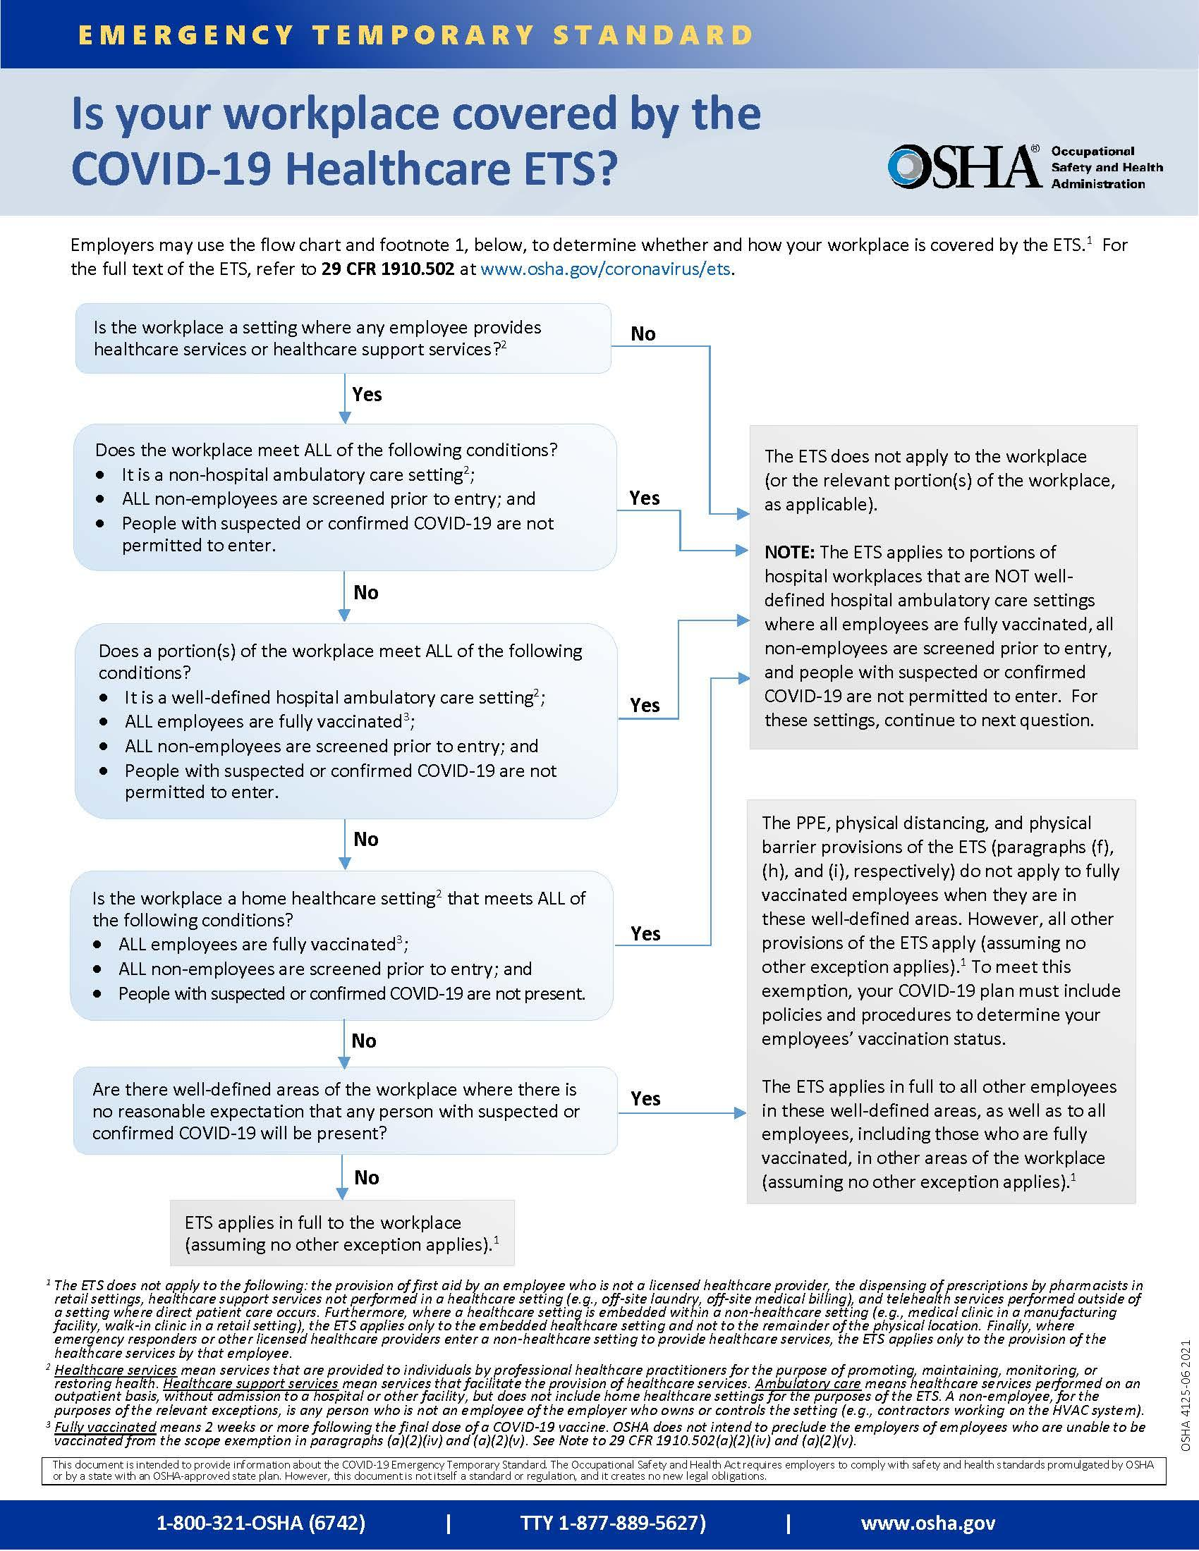

Where the establishment is determined to be covered partially or fully by the OSHA ETS, the Chief of Compliance and Industrial Hygiene Supervisor shall be notified prior to inspection.

By and Under the Authority of:

__________________________________________
Michael A. Penn CSP, SMS
Acting Assistant Commissioner

cc: Matthew S. Helminiak, Commissioner, Division of Labor and Industry

