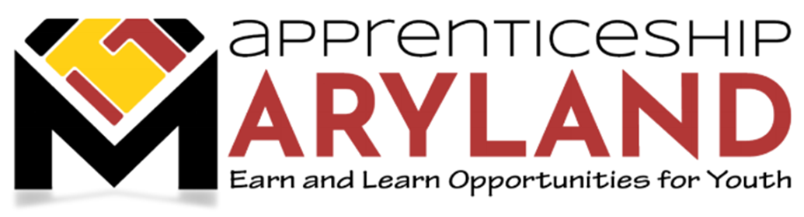
Youth Apprenticeship Advisory Committee
March 16, 2022 Meeting
Agenda

- Welcome and Introductions

- Approval of Minutes

- Discussion Regarding Status of Apprenticeship Maryland Program (AMP)

- Review statistics from Current Youth Apprenticeship Program Overview document (attached)
- Current AMP youth apprentices by industry of focus
- Current average hourly wage
- Current 2021-2022 Registrations to date

- MSDE Update – 2021-2022 School Year Information – AMP Coordinator meetings

- Policy Update – Status of Policy Development Process, Update regarding Youth Employer Outreach Calls, New Procedures for Communication with Businesses and school Systems

- Legislative Update – 2022 Legislative Session - SB 318/HB 652, SB 420/HB 719, SB 422/HB 750, SB 478/HB 541

- Marketing Update – SAE 2020 Supported Statewide Marketing Campaign

- Other Business – Graduation Cords/Completion Certificates

